HOP 4.1

HOP 4.2

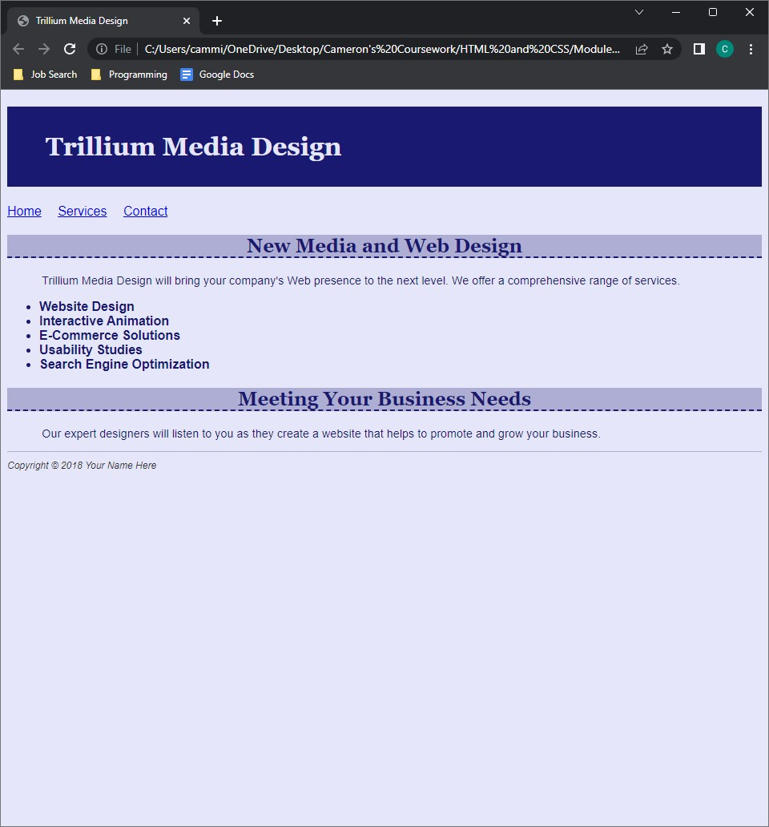

HOP 4.3

HOP 4.4

HOP 4.5

HOP 4.6

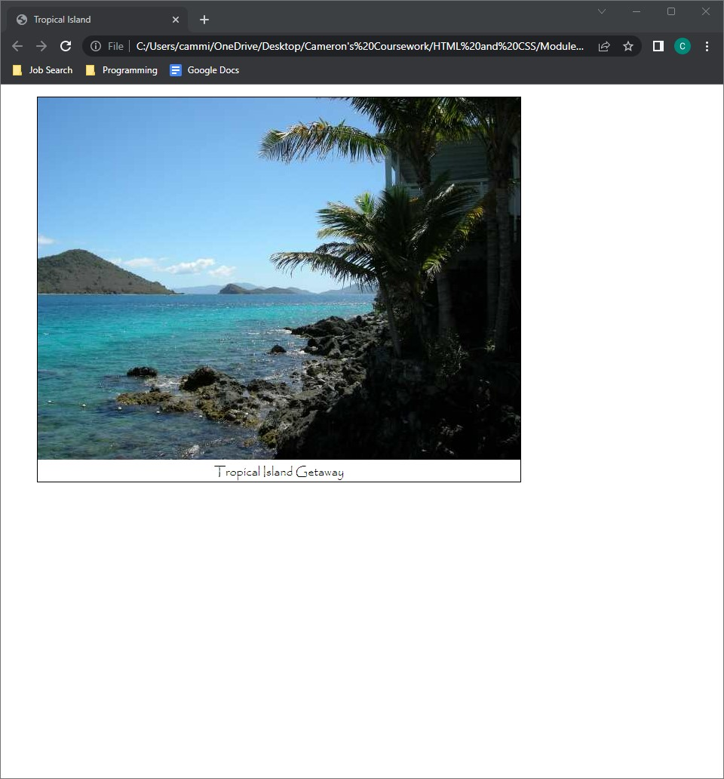

HOP 4.7

HOP 4.8

HOP 4.9



HOP 4.10

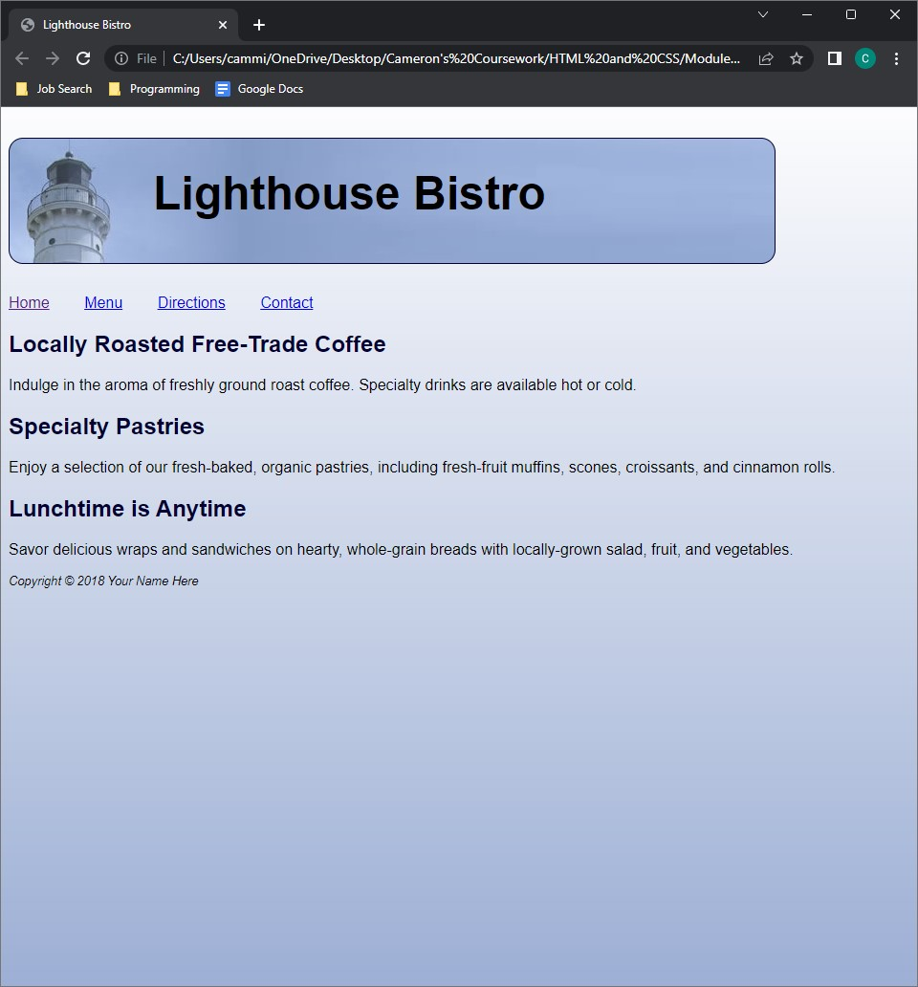

HOP 4.11

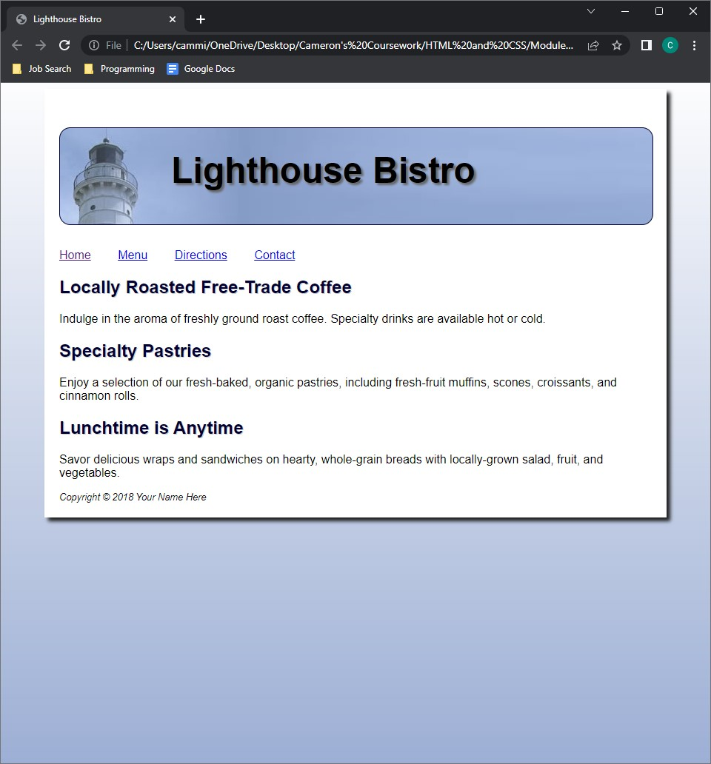

HOP 4.12



HOP 4.13



HOP 4.14



HOP 4.15

HOP 4.16

